

Republic of the Philippines

Department of Education

Region V

Division of Sorsogon

**TIONG HEN SO MEMORIAL HIGH SCHOOL**

Bon-ot Big, Matnog, Sorsogon

S.Y. 2022 – 2023

**1st QUARTER EXAMINATION**

**GRADE 10**

**MUSIC**

*MULTIPLE CHOICES*

Direction: Choose and write the letter of your answer.

1. This type of music reveals the composer’s mind, instead of presenting an impression of the environment.
2. Impressionism C. Electronic Music
3. **Expressionism**  D. Jazz Music
4. The composer who changed the course of musical development by dissolving traditional rules and conventions into a new language of possibilities in harmony, rhythm, form, texture, and colour.
5. **Claude Debussy**  C. Arnold Shoenberg
6. Maurice Ravel D. Richard Wagner
7. An Element of Music that refers to the sound quality of the instrument or voice.
8. Melody C. **Timbre**
9. Tempo D. Form
10. This kind of music centered on nature and its beauty, lightness and brightness.
11. Electronic Music C. **Impressionism**
12. Expressionism D. Jazz Music
13. An Element of Music that refers to the length of notes and rests in music.
14. Form C. Harmony
15. Melody  **D. Rhythm**
16. Many of his works deal with water in its flowing or stormy moods as well as with human characteristics.
17. Claude Debussy C. Arnold Shoenberg
18. **Maurice Ravel** D. Richard Wagner
19. Among the voice categories, which of the following refers to the *highest voice* of *Females*?
20. **Soprano**  C. Tenor
21. Alto D. Bass
22. An Element of Music that refers to the volume within a song.
23. Melody C. Harmony
24. Tempo **D. Dynamics**
25. A musical composer who gradually turned his tonal preference to dissonant and atonal as he explored the use of chromatic movement.
26. Claude Debussy C. Richard Wagner
27. Maurice Ravel D. **Arnold Shoenberg**
28. He is known as the *“Father of Modern School of Composition”.*
29. **Claude Debussy**  C. Richard Wagner
30. Maurice Ravel D. Arnold Shoenberg

**ARTS**

*MULTIPLE CHOICES*

Direction: Choose and write the letter of your answer.

1. A style of painting that used a more scientific analysis of color to capture the effects of light in nature.
2. Dadaism **C. Impressionism**
3. Expressionism D. Cubism
4. Which of the Elements of Art refers to the recognizable path created by a point moving in space?
5. **Line** C. Texture
6. Space D. Value
7. An Artist who is best known for landscape paintings, particularly those depicting his beloved flower gardens and water lily ponds.
8. Auguste Renoir C. Paul Cezanne
9. Edouard Manet **D. Claude Monet**
10. An Art Movement that works with more emotional force, rather than with realistic or natural images.

A. Dadaism C. Impressionism

**B. Expressionism** D. Cubism

1. Which of the following refers to the surface quality of an object?
2. Line C. Form
3. Space  **D. Texture**
4. The Art Movement that expresses the artist’s role in social reform.
5. **Social Realism**  C. Dadaism
6. Surrealism d. Futurism
7. His works were remarkable for their strong, heavy brush strokes, intense emotions, and colors that appeared to almost pulsate with energy.

**A. Vincent Van Gogh** C. Paul Cezanne

B. Edouard Manet D. Claude Monet

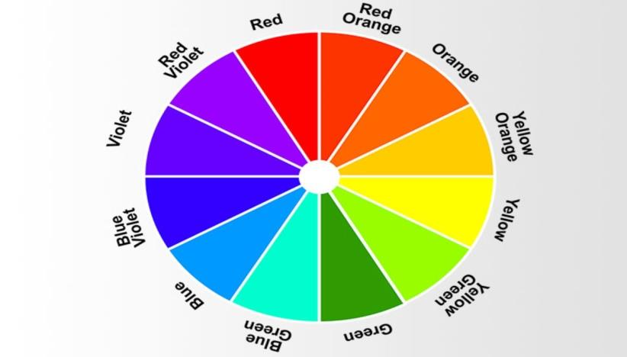For numbers 18 – 20 refer to the picture.

1. What is the complementary color of *Yellow*?
2. Orange C. Red
3. **Violet** D. Blue
4. Which of the following shows *analogous colors*?
5. Blue, Green & Yellow C. Violet, Yellow-Orange & Yellow-Green
6. **Red, Red-Orange & Orange** D. Blue-Violet, Red-Violet & Yellow
7. What are the Split-Complementary colors of *Red*?
8. **Blue-Green & Yellow-Green** C. Yellow-Orange & Yellow Green
9. Red-Violet & Blue-Violet D. Red-Orange & Yellow Orange

**PHYSICAL EDUCATION**

*I - MULTIPLE CHOICES*

Direction: Choose and write the letter of your answer.

1. It refers to the way in which an individual lives.
2. Physical Fitness C. Physical Education
3. **Lifestyle**  D. Habits
4. What will happen when your energy consumed is lesser than your energy expended.
5. Weight Gain C. Weight Maintenance
6. Weight Loss D. Overweight
7. In order to compute for your BMI (Body Mass Index) you’re going to first need to know your height and weight. How will you compute for your BMI?

2

1. Height(m)+Weight(kg) C. Height(m)/Weight(kg )

2

1. Weight(kg)/Height(m)  **D. Weight(kg)/Height(m )**
2. Yana’s weight is 53 kilograms and her height is 1.72 meters and Yana’s computed BMI is 17.91, what is Yana’s BMI Classification?
3. **Underweight**  C. Overweight
4. Normal D. Obese
5. Emma is 18 years old she wants to know her BMI Classification. If Emma’s computed BMI is 19.56, what is Emma’s BMI Classification?
6. Underweight C. Overweight
7. **Normal**  D. Obese

*II - CLASSIFICATION*

Direction:

* The table is divided in to two columns (Health-Related and Skill Related Physical Fitness)
* In order to fill the table, use the word/s inside the box.
* Classify whether the word/s belongs to neither Health-Related or Skill Related Physical Fitness.
* Write your answer in your answer sheet.
* **Cardio Respiratory - Muscular Endurance**
* **Speed - Coordination**
* **Balance - Reaction Time**
* **Flexibility - Power**
* **Agility - Strength**

|  |  |
| --- | --- |
| **Health Related Physical Fitness** | **Skill Related Physical Fitness** |
| 26. | 31. |
| 27. | 32. |
| 28. | 33. |
| 29. | 34. |
| 30. | 35. |

**HEALTH**

*I - MULTIPLE CHOICES*

Direction: Choose and write the letter of your answer.

36. This tells about the source and recency of the information.

1. **Credibility** C. Disclosure
2. Content D. Interactivity

37. This refers to the programs we avail from various providers such as physicians, nurses, therapists, health workers, hospitals, clinics, and the government.

A. Health Information C. **Health Services**

B. Health Products D. Health Care

38. This tells about the feedback mechanism and means of information exchange between the source and the consumer.

1. Credibility C. Disclosure
2. Content **D. Interactivity**

39. This tells about the accuracy, disclaimer, and completeness of information.

1. Credibility C. Disclosure
2. **Content**  D. Interactivity

40. This refers to those items that we consume to improve our well-being, like medicine, food, clothes, furniture, electronics, etc.

A. Health Information C. Health Services

**B. Health Products**  D. Health Care

*GOOD LUCK!*